

**Contact**

**Send you Cv’s to** [**job@mazco.com.sa**](mailto:job@mazco.com.sa)

**Or**

**Post Box: 2486, Dammam 31451,**

**KINGDOM OF SAUDI ARABIA.**

**Tell: +966 3 8260080 EXT: 31**

**Fax : +966 3 8266618**

**Website::**[**www.mazco.com.sa**](http://www.mazco.com.sa)

[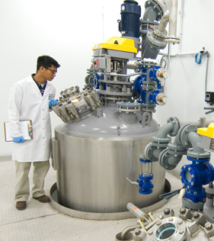](http://www.google.com.sa/url?sa=i&rct=j&q=&esrc=s&frm=1&source=images&cd=&cad=rja&docid=oXAcci_2mYsKfM&tbnid=rKKrPoBvfJf6ZM:&ved=0CAUQjRw&url=http%3A%2F%2Fwww.pharmacore.com%2Fgmpphotos.htm&ei=3alFUZj9KIe5O-KigIgK&psig=AFQjCNFRcuUSz4zeUSy6PYv7ft7Ga6Ydmw&ust=1363606346365371)

**JOB DESCRIPTION**

Instrument TechnicianShall

* Plan daily work based on work orders and job instructions received.
* Should check and troubleshoot faults on equipment and inspect equipment to identify/repair faults.
* Should carry out daily repair works.
* Implement preventative maintenance programs.
* Re installs repaired and overhauled equipment on site and undertakes workshop overhaul
* Observe all safety and loss prevention procedures
* Perform other duties such as reporting job completion and any problems encountered to supervisor.
* Perform the assigned maintenance tasks (PM/CM) in an efficient and effective manner to support equipment integrity and reliability.
* Perform assigned maintenance tasks and activities during SD/TA to support equipment integrity and reliability.
* Update and maintain the equipment maintenance history and records in Computerised Maintenance Management system to enable data acquisition and analysis and support the I&R programs.

**QUALIFICATION**

* Completion of Secondary (Science) education + 3 years formal training leading to Diploma; C&G Part III or equivalent.
* Minimum of 3 years’ experience of maintenance work in the oil or petrochemical industry.
* Very good English language skills and competent in the use of PC applications (MS Office suite or equivalent).

Instrument Technician